BBQ 2.0
Elie Jerjees
Joseph Masullo
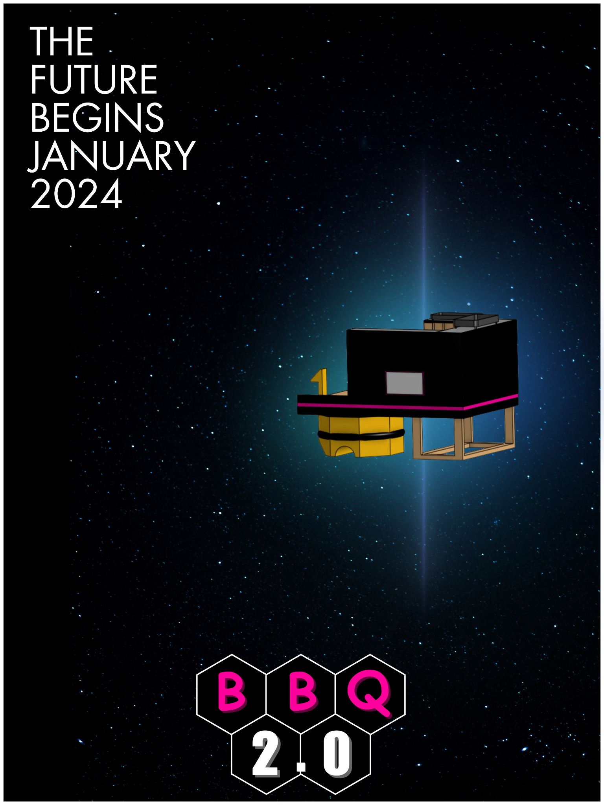

Table of Contents
Table of Contents 2
Element A: Presentation and Justification of Problem 5
Problem Statement 5
Introduction 5
Justification - Expert Interviews 7
Justification - Survey Results 11
Conclusion 14
Element B: Documentation and Analysis of Prior Solution Attempts 16
Problem Statement 16
Introduction 16
Patents 18
Patent 1: Portable BBQ Grill 18
Patent 2: Food Truck 19
Patent 3: Mobile Kitchen and Cafeteria Unit 20
Existing Products 21
Existing Product 1: Greathouse Labs Multipurpose Grill 21
Existing Product 2: Hemi Grill 23
Decision Matrix 24
Conclusion 25
Element C: Presentation and Justification of Solution Design Requirements 26
Problem Statement 26
Introduction 26
Stakeholders 27
Design Constraints 28
Conclusion 29
Element D: Design Concept Generation, Analysis, and Selection 30
Problem Statement 30
Introduction 31
Concept Sketches 32
Concept 1 “Roofed Cart” 32
Concept 2 “Adam 1” 33
Concept 3 “Adam 2” 34
Decision Matrix 36
Conclusion 37
Element E: Application of STEM Principles and Practices 38
Problem Statement 38
Introduction 38
Science 39
Technology 41
Engineering 42
Mathematics 43
Conclusion 44
Element F: Consideration of Design Viability 45
Problem Statement 45
Introduction 45
Market Analysis 46
Price Breakdown of Prior Solutions 46
Market Research 47
Conclusion 47
Element G: Creation of a Testable Prototype 48
Problem Statement 48
Introduction 48
Prototype Construction 49
Grill Platform: 49
Material Selection: 50
Conclusion 50
Element H: Prototype Testing and Data Collection Plan 52
Problem Statement 52
Introduction 52
Testing: 53
Conclusion 58
Element I: Testing, Data Collection and Analysis 59
Problem Statement 59
Introduction 59
Test Results and Data Collection 60
Structural Test 60
Rolling Test 62
Analysis 64
Conclusion 65
Element K: Reflection of the Design Project 66
Problem Statement 66
Introduction 66
Element A 67
Element B 67
Element C 67
Element D 68
Element E 68
Element F 68
Element G 69
Element H 70
Element I 70
Conclusion 70

Element A: Presentation and Justification of Problem

Problem Statement
Based off a survey taken by high schoolers it was shown that 70% of students found school events mediocre or boring, 61.9% found school provided lunch mediocre or bad, and 75.7% get hungry while traveling. Students need to be energized and have nutrients during school in order to perform their best. When they are hungry and bored they cannot be at their best. By creating a transportable grill better food options can be available to students as well as entertainment.

Introduction
The average student has a consistent cycle of day to day life. Most days going to school is repetitive and can become tiring. Lack of excitement and constant work leads to overload and stress on students, this then lowers their achievement and levels of energy. Along with this lack of nutrition and fulfillment in their diets causes lowered energy levels and lack of focus. Students’ mental and phsyical healths are at stake due to lack of attention to little things like entertainment and nutrition at school although they are at school for the majority of their week. These issues coupled together causes students to become more unhealthy and less able to succeed academically.

A few of these issues have had attempts at being tackled. To improve mental health students are given resources like counseling and therapy. For nutrition, lunch is provided and appropriate time is given to eat and socialize. There are occasional attempts at entertainment, for example, pep rallys, theater performances, and after school activities.

While these issues are seen and solutions are attempted, there is no permanent fix and the solutions are not enough. Occasional entertainment is too limited considering students are at school for 9 months at a time and are only given 1 to 2 pep rallys and maybe 1 theatrical performance per year. Furthermore, those activities are seen by students as lacking and boring. Meals are given to students, but they are required to pay and have limited options to decide between. Along with this many students find the meals to be mediocre and unfulfilling. Due to unfulfilling meals and an unproportionate amount of work to entertainment, student's mental healths are affected and even with school resources provided, the initial cause is not fixed, so the problems continue.

Justification - Expert Interviews
Name | Kieth Bernhard
Background | Retired Electrician/Technician  Engineering Teacher
How would you go about making a grill portable with limited resources? | I’ve done a project similar to this before, me and my boss took it on and we built a smoker using unused water tanks, one to create the smoke and another to put the food in. We found a trailer that could hook up to a truck and put the whole smoker on there to make it portable. However, that was an expensive project, but you wouldn’t need all the parts that we used.
Would you suggest a propane tank or charcoal grill? Why? Which would be safer seeing as how the grill will be driven around? | Charcoal, always charcoal. Charcoal would be the safer option, especially since the grill would be moving around. Charcoal is also just a better way to cook.
We need a platform to attach the grill to the transportation mechanic, what material would you suggest? It needs to hold a lot of weight and also be heat and flame resistant. | All you would really need is 4 wheels, unless you are attaching it to something else. You could try to mount it on top of Adam (school agv).
What transportation method would you suggest to pull or hold the grill and maybe a person? | You could give Adam a try, you would just mount it directly on top, but you would need to find a way to mount it safely. It can carry a lot of weight, I’ve had multiple students ride it and be pulled by it.
Would it be better to have the grill be pulled or be able to lift it? | It would be better to build a platform on top. If you use the AGV, you could pull it or lift it and it wouldn’t make much of a difference.
How would you make the grill drivable? (for example pull the weight while also holding someone) | Make it drivable by using a AGV with the provided way of control. The AGVs can drive easily with someone controlling it.

Name | Rudy Daood
Background | Car Mechanic  Owner of Rudy’s Garage
What do you think would be the best way to make a grill transportable? | Throw some wheels on it, push it around. If you want it to move without pushing it you could put motors on it, but then you would need to have a lot more parts. If you have the materials that’s the most efficient way.
Would you recommend attaching a grill to a preexisting mechanism that drives or attach wheels and motors to the grill itself? | Attaching the wheels and motors would be much more interesting, but it would require a lot more car parts that would be hard to get. If you have something to attach it to that would be a better solution. Maybe a lawn mower, golf cart, or even a quad.
How strong of a battery would we need if we were to power electronics on the grill (monitors, speakers, minifridge)? | A car battery could be enough power if it was a smaller fridge, the other things would easily be powered by a car battery. If you have a bigger mini fridge you would need something with more amps to power it for a long time.
Is there a way to stabilize the grill on something moving more securely? | The best way to secure it is to bolt it down. It depends on what you want to attach it to, but bolting it down is the most secure way.
What is the best material to securely attach a grill to something moving? | If you’re using something as heavy as a grill wood is probably your best option. You need it to be stable if you want to use the grill while it’s moving so I would go with wood.

Justification - Survey Results
Question | Reflection
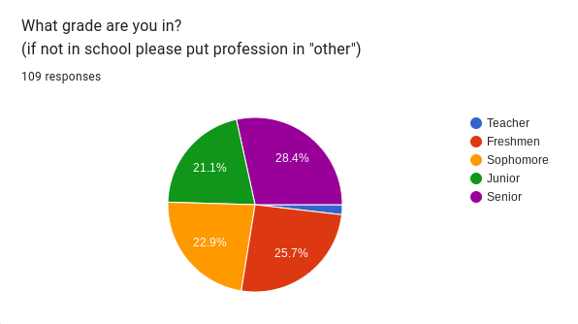 | We received responses split almost into a forth from the different grades, other then the two responses from teachers.
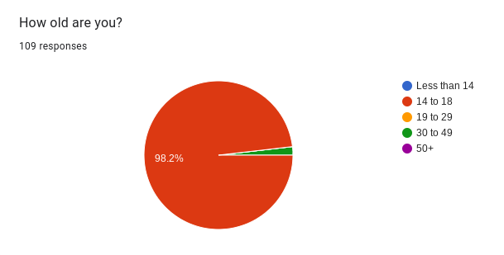 | The majority (98.2%) of the data is in the age range of 14-18. With the two teachers being in the 30-49 range.
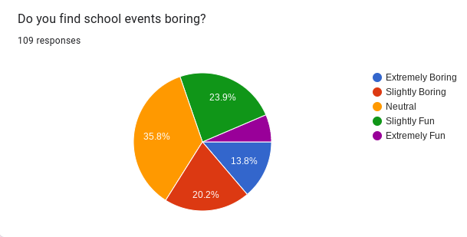 | 30.3% of responses said that either school events were either slightly/extremely fun, compared to the 69.8% who said neutral to extremely boring.
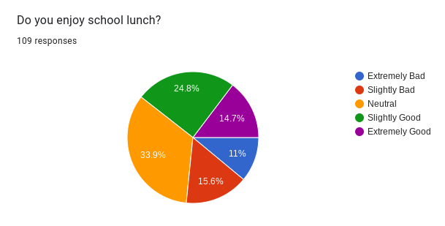 | 39.5% of responders stated that they thought school lunch was either slightly / extremely good while 33.9% were neutral on the topic and 26.6% were not fans of school lunch.
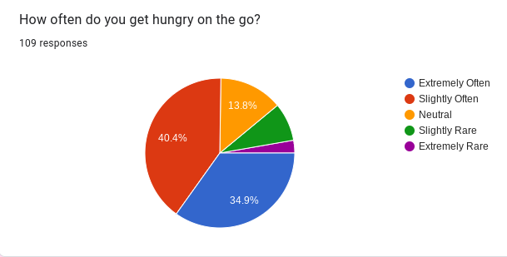 | A large number of responders (75.3%) said that they get hungry on the go. 13.8% were neutral and 11.1% said that its slightly / extremely rare.
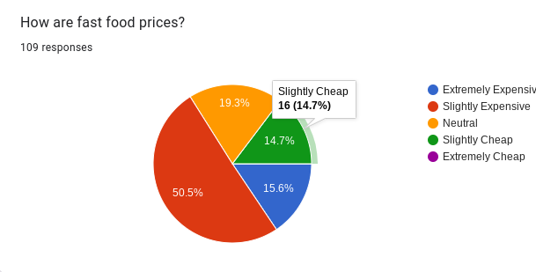 | Over half of responders (50.5%) said that fast food was slightly expensive while 15.6% said extremely expensive. 19.3% stated neutral, 14.7% stated slightly cheap. 0% of responders said extremely cheap.
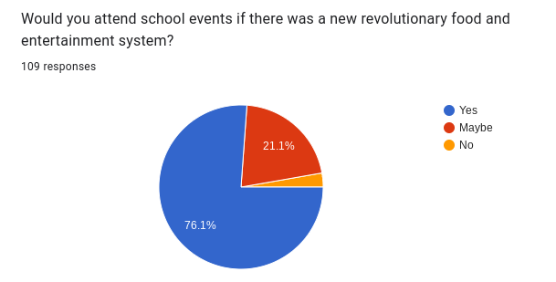 | The vast majority of responders (76.1%) said that they would be more willing to attend school events if the new food and entertainment system was there. We also had 21.1% of responders state they may attend.

Conclusion
After careful consideration, extensive surveying, and thorough research it is clear that excessive hunger and lack of excitement during school leads to less academic ability. Through multiple interviews it was proven that it is solvable and with a solution will end the issues students face. By eliminating the forementioned issues, students day to day quality of life and mental health will increase as stress decreases and grades improve. It is an important issue that is facing students because it affects their current education and their future when an easy solution can have a lot of impact.

Element B: Documentation and Analysis of Prior Solution Attempts

Problem Statement
Based off a survey taken by high schoolers it was shown that 70% of students found school events mediocre or boring, 61.9% found school provided lunch mediocre or bad, and 75.7% get hungry while traveling. Students need to be energized and have nutrients during school in order to perform their best. When they are hungry and bored they cannot be at their best. By creating a transportable grill better food options can be available to students as well as entertainment.

Introduction
During Element B, our team began to research prior solutions and patents to our problem. Using our finalized problem statement we were able to narrow down what we were looking for and what would fulfill the criteria. We began our search on google patents because it is a efficient site for patents which allows for easy and accurate searching. Google patents shows you the inventor(s), patent number, description, and gives pictures of the product. This makes it a very useful source for research. After much research a couple of patents with a similar purpose and problem were found. Our group went through the descriptions to find the details and design process of each. We found pros and cons of each product to determine what we could use in our own solution and what we would try to avoid as well as try to figure out why they did not go to market. We then searched for prior solutions that did not have a patent, their are many inventors who do projects just for craftsmanship. We found two solutions that were very similar to our initial concepts. We listed the pros and cons of each as well as the design that was used in each product. Some of the prior solutions and patents were more on par with our ideas while some had ideas that were taken into consideration for our own solution.

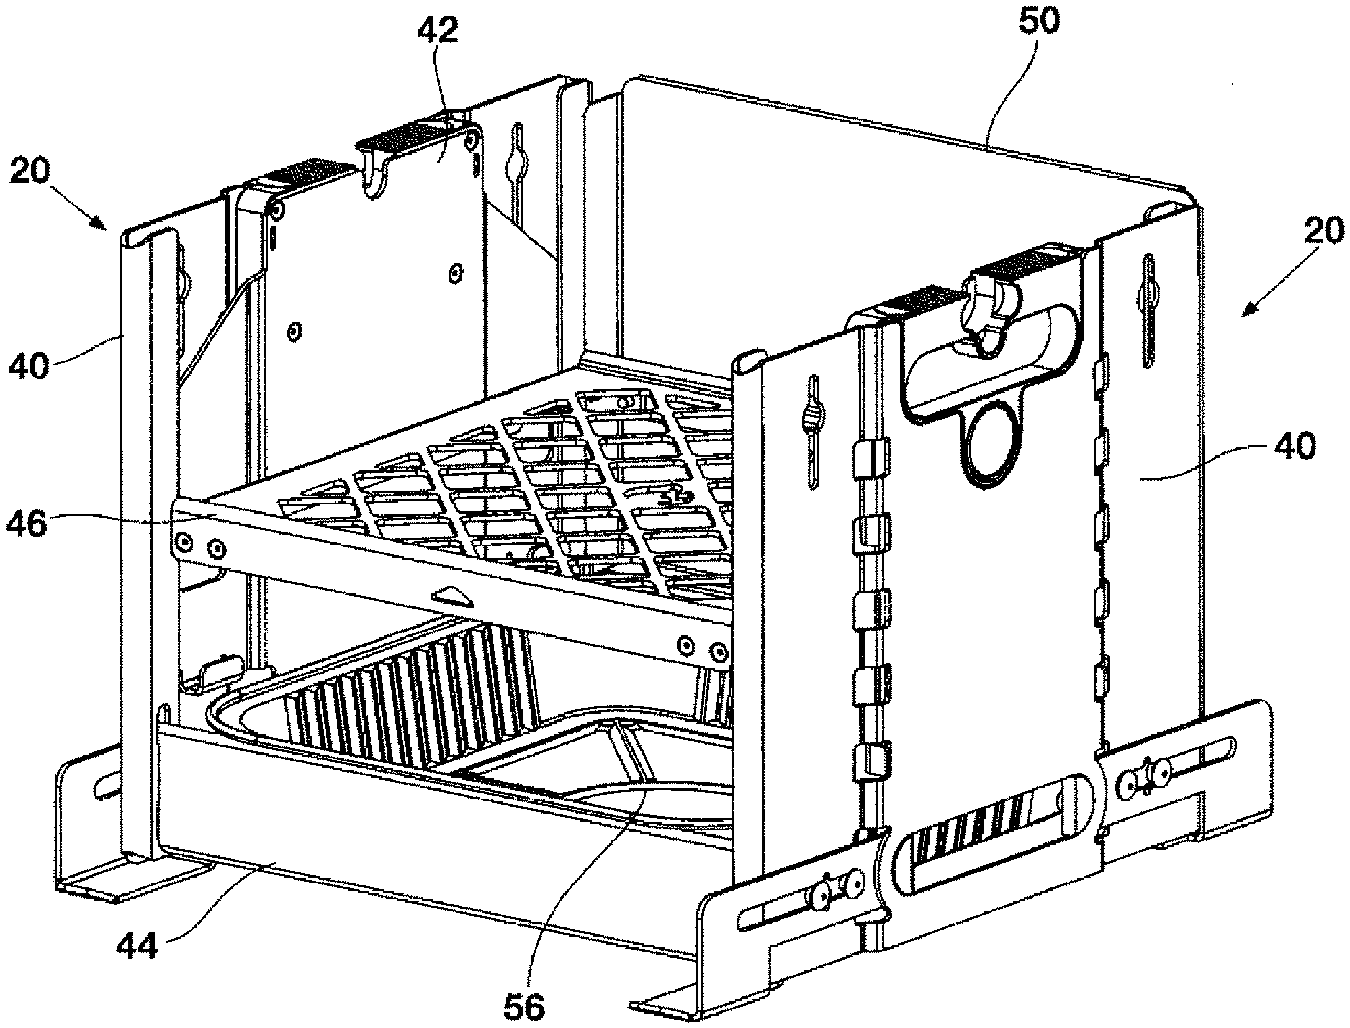
Patents

Patent 1: Portable BBQ Grill
Patent # - US20230204218A1
Inventors - Gerard Thibault, David Andrew McMullin, William Dicke
Publication Date - 2023-06-29
Abstract - Disclosed is a BBQ Grill comprising two lower side panels, two upper side panels that are slideably received in the lower side panels. Crossbraces space the panels apart and a grill plate is adapted to detachably engage hooks on the upper side panels. The grill has legs that extend and retract associated with the lower side panels and the upper side panels have a handle assembly with a button to set pawls of a latch plate at selected apertures associated with the lower side panel. Various accessories are disclosed. The grill can be used with wood, charcoal briquettes or a gas burner.

Pros: | Cons:
It is lightweight | It cannot be driven
Adjustable | It is small and can’t fit much
Easy to use | Unsecure
Thibault, G., McMullin, D. A., &amp; Dicke, W. (2023, June 29). Portable BBQ grill.

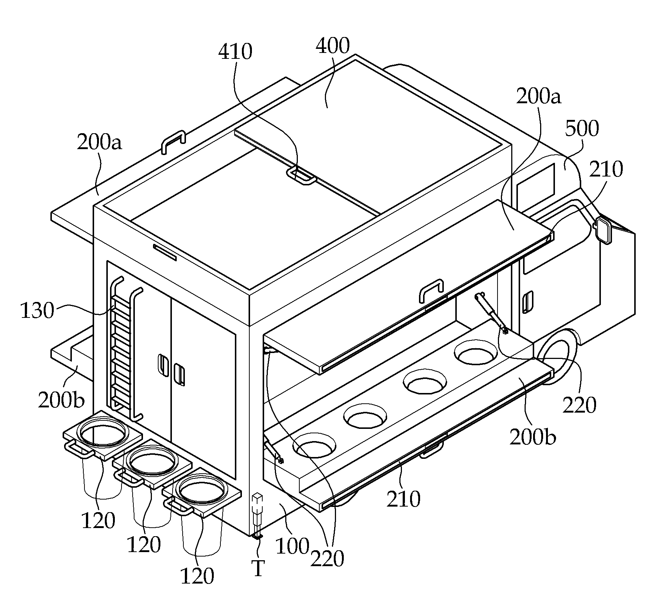
Patent 2: Food Truck
Patent # - KR101743373B1
Inventors - Chai Jong, Na Wanyong
Publication Date - 2017-06-05
Abstract - The object of the present invention is to provide a food truck which enables a wide use of the internal space of a loading box having a limited internal space and at the same time enables use of both doors as a ceiling and a table, have.
Particularly, the present invention can provide a sufficient amount of water for cooking and washing dishes by mounting a drinking water tank on the bottom of a loading box, There are other purposes for providing trucks.
In addition, the present invention is configured such that the upper door and the lower door used as the ceiling and the table can be extended in a sliding manner, respectively, so that a large number of customers can be accommodated and the hood truck can be conveniently used without being exposed to the sun.
Pros: | Cons:
Has space for multiple customers to sit | Takes up a lot of space
Has flaps to close off the truck | Takes fuel to run
Can hold multiple people inside to cook | Expensive to create
Jong, C., &amp; Wanyong, N. (2017, June 5). Food truck.

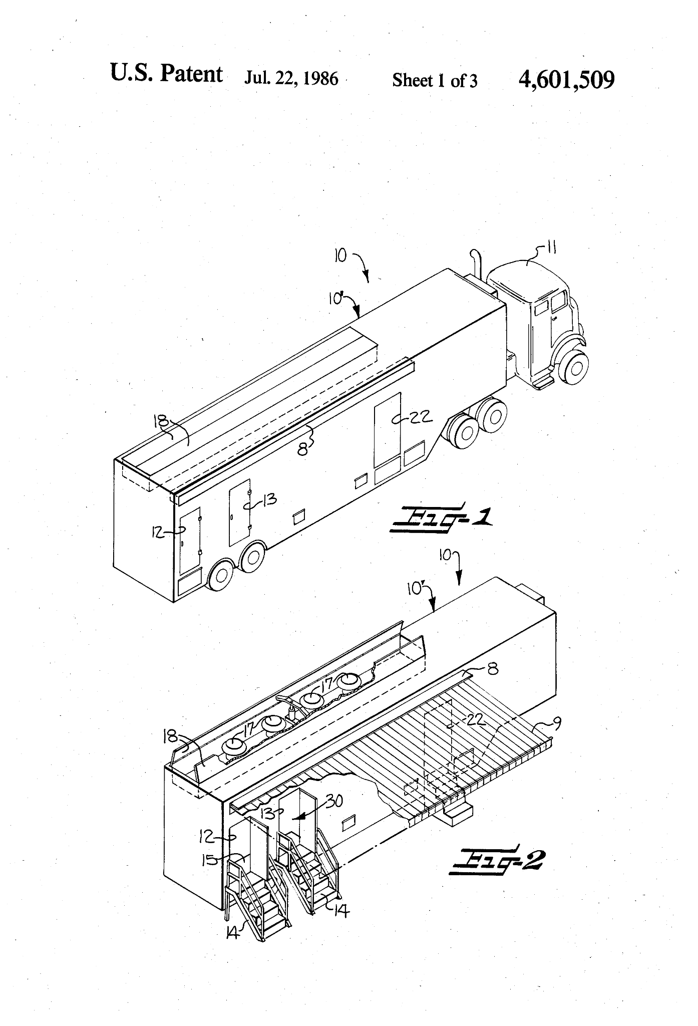
Patent 3: Mobile Kitchen and Cafeteria Unit
Patent # - US4601509A
Inventor - William L. Ellis
Publication Date - 1986-07-22
Abstract - A combination mobile kitchen and cafeteria unit is provided which comprises an elongate wheeled walled enclosure having ingress and egress patron passageways along a side wall thereof with a patron serving aisle within the enclosure communicating with the ingress and egress passageways and along which aisle extend facilities for serving food and beverage. Also provided are attendant facilities for food and beverage storage and preparation, cooking, food cooling and washing.
Pros: | Cons:
Has much more space for cooking and seating | Very large
A lot more sturdy | Would be very expensive to construct
More storage space | Inconvenient for schools
Ellis, W. L. (1986, July 22). Mobile kitchen and cafeteria unit.

Existing Products

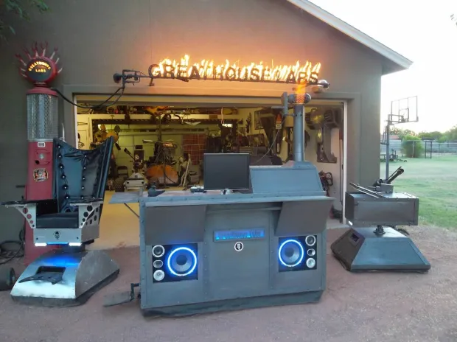
Existing Product 1: Greathouse Labs Multipurpose Grill

Drivable Grill
Cost: $650
Description: “For the tailgate rig, he started by gathering the parts: a used grill from Craigslist, an inexpensive wine refrigerator, a discarded flat-screen monitor, an electric wheelchair”
“The grill and fridge sit at opposite ends, and Greathouse installed the controls for the electronic components in between. The rig has neon light effects on the front, a satellite stereo, an MP3 player, 250-watt speakers, a camera that displays tailgaters on the TV screen, and a second camera that relays a video feed of what’s cooking under the grill hood to a laptop. For fun, he added a steel cylinder that shoots fireballs into the air. A battery-powered inverter runs it all when there isn’t an available generator to plug into”.
Pros: | Cons:
Compact but uses space efficiently | Uses an electric wheelchair as the mode of transportation
Aesthetically pleasing with a lot of detail | Separate attachments for seating
Has a multitude of multimedia features | Standing pad is small with little room for movement
Mone, G. (2011, June 23). The ultimate tailgating station combines a TV, wine refrigerator, and Grill. Popular Science. https://www.popsci.com/diy/article/2011-06/ultimate-tailgating-contraption-wraps-tv-wine-refrigerator-and-grill-all-one/

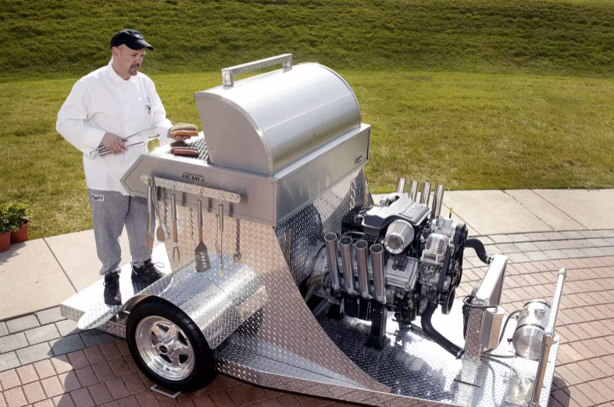
Existing Product 2: Hemi Grill

Hemi Grill
Cost: Unavailable
Description: Chrysler Group's one-of-a-kind HEMI-powered grill at an event to announce the top five finalists in the company’s "What Can You HEMI?" contest. Until the event, the HEMI engine was only found in Chrysler, Jeep or Dodge vehicles. With the power and torque of the 5.7-liter V-8 HEMI engine, the grill can cook 240 HEMI dogs in three minutes and is covered by more than 330 square feet of steel.
Pros: | Cons:
Space for cooking tools | Gasoline near the food
Movement power is high | Standing room is narrow
Large Grill | Expensive to construct
Hanlon, M. (2015, May 2). 345 horsepower, 5.7-liter Hemi V-8 engine powered barbeque. New Atlas. https://newatlas.com/345-horsepower-57-liter-hemi-v-8-engine-powered-barbeque/4397/

Decision Matrix
Scale of 1 to 5, 1 being the worst and 5 being the best.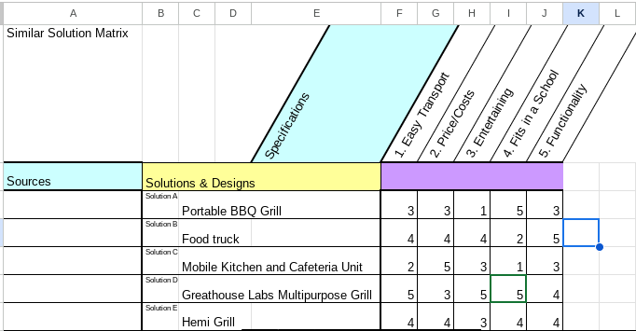

Conclusion
In Element B our group researched 3 patents and 2 prior solutions with no patents. We found pros of cons of each such as some being too big while some being too small, some using too much materials or being too expensive, and some simply not fitting into our criteria. Some pros that were found were the efficiency of movement and the adjustability of certain solutions which we want to implement in our own solution. We found design specifications, drawings, sketches, and models of each product to help visualize the solution. Each product ranged in variation from size to design to purpose, but all had the main goal of making a portable solution to a BBQ Grill. Using the information gained from the previous element we were able to determine which features from each prior solution would be best to attempt to implement in our own solution so it fits the criteria wanted by the survey takers in order to solve the problem. The advice given by our experts helped to narrow down which prior solution would be the best to fit our purpose and which would be most efficient.

Element C: Presentation and Justification of Solution Design Requirements

Problem Statement
Based off a survey taken by high schoolers it was shown that 70% of students found school events mediocre or boring, 61.9% found school provided lunch mediocre or bad, and 75.7% get hungry while traveling. Students need to be energized and have nutrients during school in order to perform their best. When they are hungry and bored they cannot be at their best. By creating a transportable grill better food options can be available to students as well as entertainment.

Introduction
When we started the design process we took what we knew would entice people to attend school events due to our product. We also looked at previous examples to help us design something that would function how we wanted it to. Now we look at who we should cater to; which groups of people would be interested in our project and who could use it. We also look at what design requirements and constraints we need to have on our product. We want to look for what is necessary to have a plausible design as well as other constraints to fit our own wants and our stakeholders wants. In Element A, we took surveys asking what consumers would like to see in our product and we intend to implement as many of those suggestions as possible.

Stakeholders
Who | Why
Students | Gives students a reason to visit school events.
Schools | Provide new levels of entertainment to school events.
Grill Enthusiasts | Provides a new experience to people who are into grilling.
Restaurants | Allows for restaurants to go mobile at a low cost.
Food Truck Companies | Provides a new and more compact experience to a related companies lineup.
Camps | Allows for a small compact entertainment center to serve a camp.

Design Constraints
What | Why
The product must be small and compact. | The product needs to be able to fit inside a school setting.
Must be cost efficient | Being cost efficient will make the project viable for other schools to implement.
Must be stable | Since the product should hold people and a grill, it must be stable and everyone should be safe.
Must be entertaining | So the number of students going to school events increases.
Must meet health standards | We want to make food on this project and provide the food to students and faculty, so the food must be cooked sanitarily.
Must be driveable | Our initial idea is for our product to be transportable so we want it to be able to drive without manually pushing the grill.

Conclusion
Through thorough research it has been shown that there were many attempts to solve our issue. Although there are many, we could not find one that fits all the criteria we need to fulfill. We listed all the constraints we needed on our own product as well as finding who would be a stakeholder of our project and what they would want in the product as well. The constraints we put were ones to create safety in the product, create efficiency, and create appeal. We limited our stakeholders to be school related in order to keep our initial goals of being meant for the school.

Element D: Design Concept Generation, Analysis, and Selection

Problem Statement
Based off a survey taken by high schoolers it was shown that 70% of students found school events mediocre or boring, 61.9% found school provided lunch mediocre or bad, and 75.7% get hungry while traveling. Students need to be energized and have nutrients during school in order to perform their best. When they are hungry and bored they cannot be at their best. By creating a transportable grill better food options can be available to students as well as entertainment.

Introduction
For Element D we began creating sketches and designs to solve our problem. We started off first by planning exactly what we needed. We had to design for our product to fit in doorways, be moveable, accessible, and hold the weight of a grill and one or more people. Our first sketch was of a roofed car, almost like a street car. This design was created to fit multiple people and a lot of equipment. Our second was to use an AGV to pull around the grill by putting it on a platform that can also hold people. Our third design was a sketch that fixed any issues with the second design and making it more stable and efficient. We used a decision matrix to decide which of these sketches was more plausible, efficient, and cost effective. We came to the conclusion that our last design, a platform with a grill attached to the top and pulled by an AGV was the best choice.

Concept Sketches

Concept 1 “Roofed Cart”
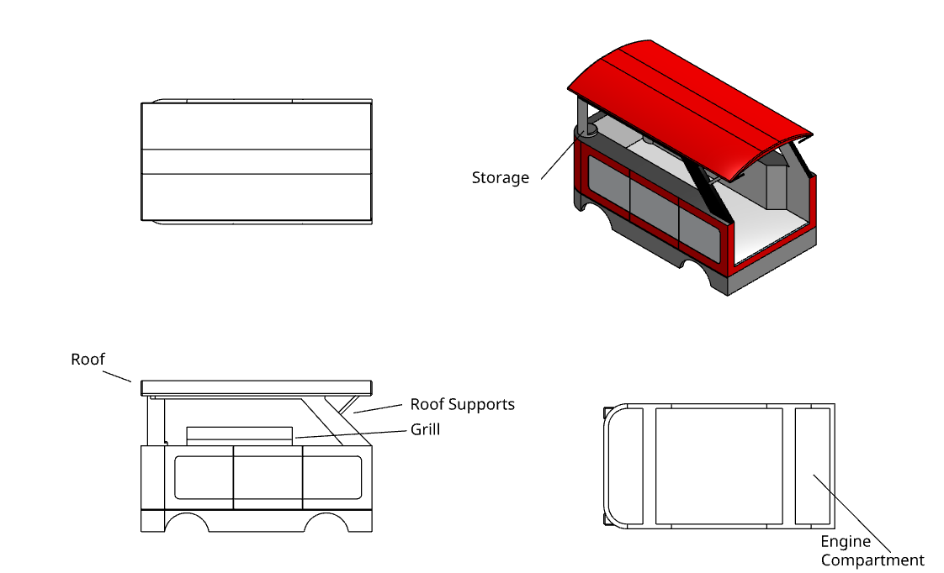
Description:
- Has a hard mounted angled roof to protect people inside from the elements.
- Has Storage built into the structural features as well as cabinets on the inside.
- The Underside of the car has space for the 4 wheels and engine.
- Grill is mounted on top of the right side countertop.
- Would be made out of Wood, Metal, and a variety of side panels.

Concept 2 “Adam 1”
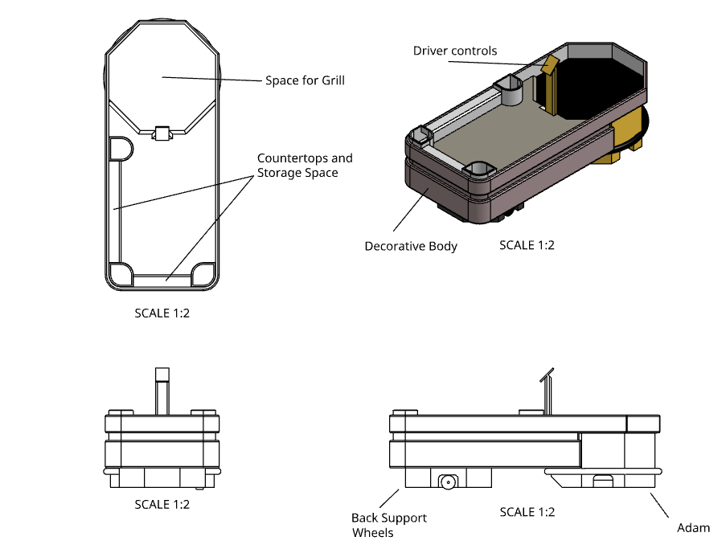
Description:
- Connects with an AGV (Adam) to be able to move.
- Large amounts of storage with cabinets and countertops spanning the base.
- Omni support wheels in the back to both stabilize and allow the cart to move with Adam.
- Control panel to be able to use Adam.
- Dedicated space for the Grill.
- Made out of various sizes of wood 2x4’s and Plywood.

Concept 3 “Adam 2”
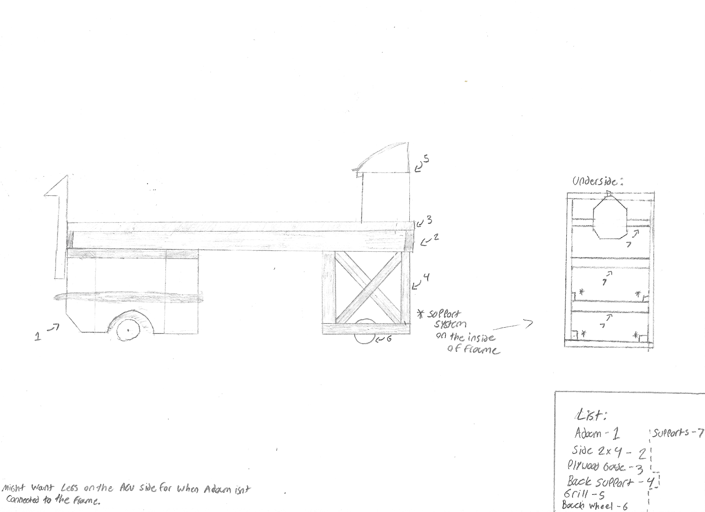
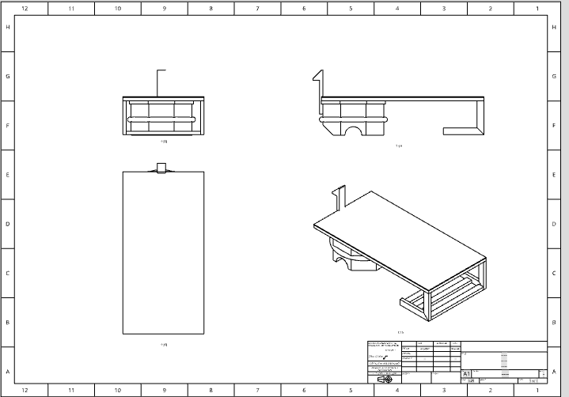
Description:
- Connects with an AGV (Adam) to be able to move.
- Omni support wheels in the back to both stabilize and allow the cart to move with Adam.
- Control Panel to operate Adam.
- Large supported platform.
- Grill is spaced out from the controls.
- Simple design that can be easily modified.
- Made out of various sizes of wood 2x4’s and Plywood.

Decision Matrix
 | Cost Efficient | Time  Efficient | Difficulty | Aesthetics | Total
Roofed Cart | 1 | 1 | 1 | 5 | 8
Adam 1 | 3 | 2 | 2 | 4 | 11
Adam 2 | 5 | 5 | 4 | 3 | 17
Scoring Key: | 1= Worst | 5=  Best

Conclusion
After relentless designing and modeling. We narrowed all our choices down to three potential solutions.We finalized our choice using a decision matrix using cost efficiency, time efficiency, difficulty, and aesthetics as our factors. The design that fit our factors the best was the second AGV based model because it would be the best decision considering our materials, time, budget, and skill level. The design consists of a wooden platform being raised by the AGV that will pull it. On the other side of the platform is a grill with a compartment below to support the platform and hold the grill. This design will be the most stable and efficient and that is why it was chosen.

Element E: Application of STEM Principles and Practices

Problem Statement
Based off a survey taken by high schoolers it was shown that 70% of students found school events mediocre or boring, 61.9% found school provided lunch mediocre or bad, and 75.7% get hungry while traveling. Students need to be energized and have nutrients during school in order to perform their best. When they are hungry and bored they cannot be at their best. By creating a transportable grill better food options can be available to students as well as entertainment.

Introduction
For Element E, we began to list out how we used the four different principles of STEM. The four principles are Science, Technology, Engineering, and Math. STEM is vital in this project because every aspect of construction and preparation uses STEM. STEM integrates all the aspects of Science, Technology, Engineering, and Math to create an efficient solution to our problem. We used engineering to build and construct, science to plan and gather materials, math to plan and prep everything with the correct measurements, and technology by using tools to put all those aspects together.

Science
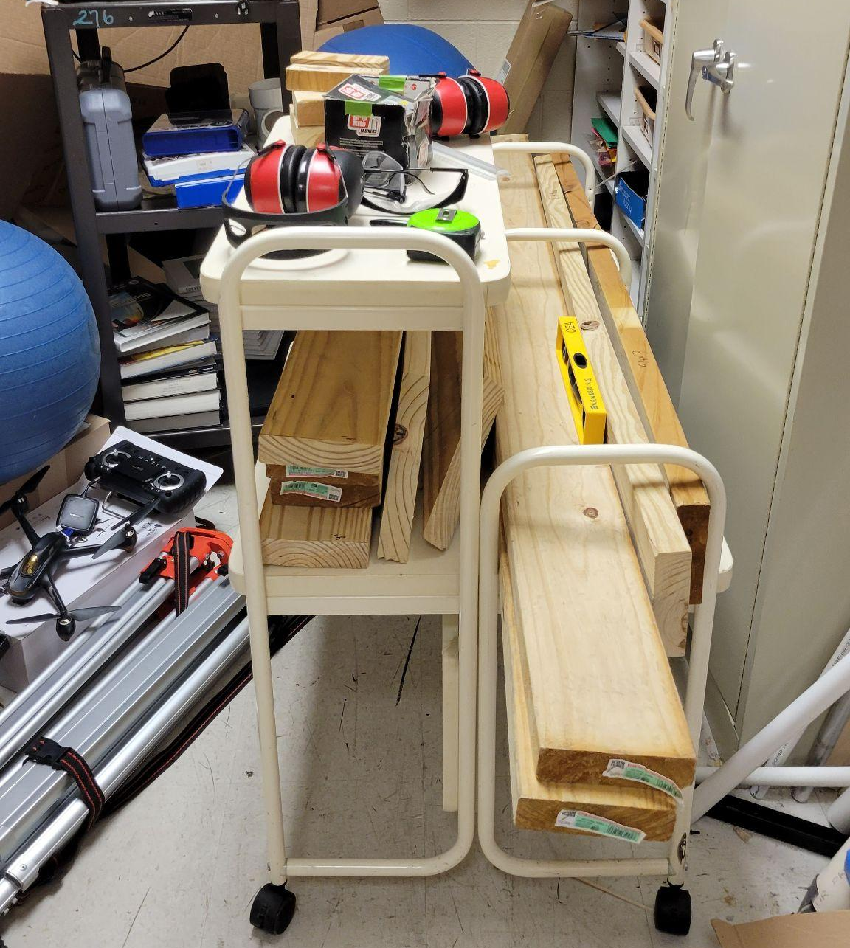 | Explored material properties to determine which material would create the strongest platform.
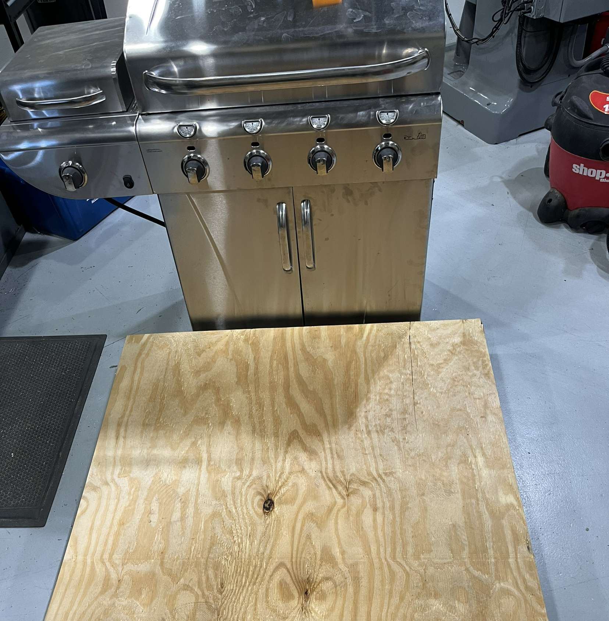 | We did tests on our platform to guarantee that it will be able to hold both multiple people as well as the grill.

Technology
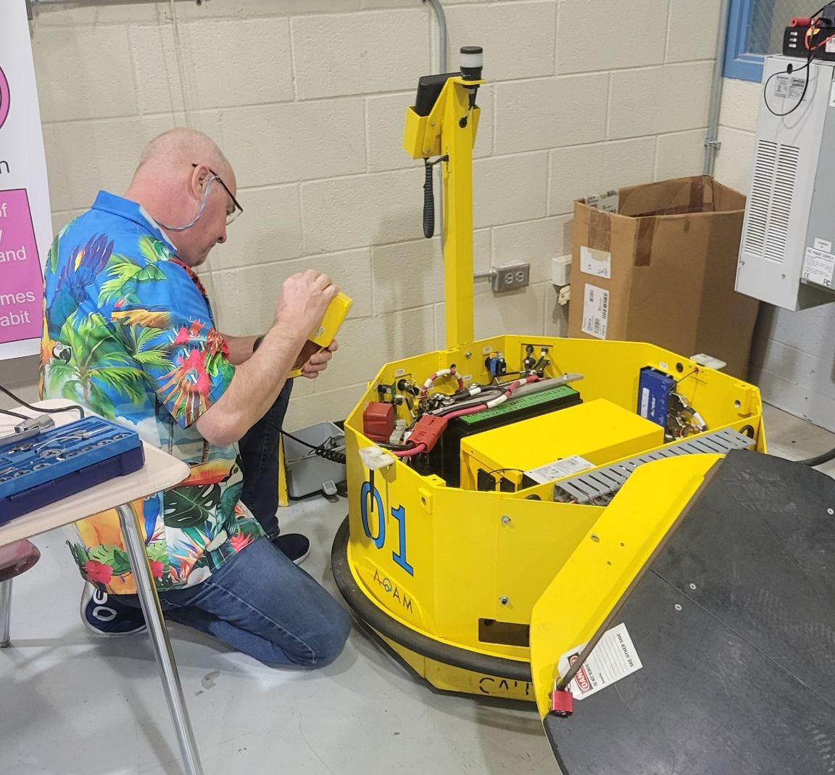 | Using an AGV for our transport device. Being able to operate it and move it automatically.
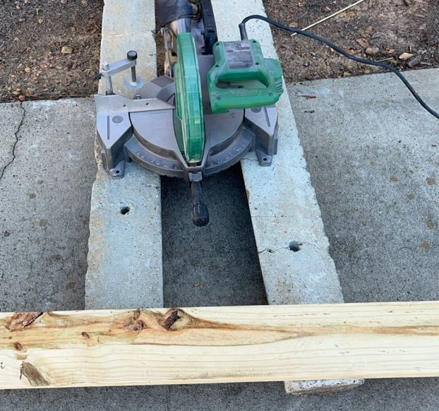 | Used a wood cutting blade to cut our wood to precise measurements.

Engineering
 | We sketched design solutions for our project to plan what materials are needed, how our product would look, and show what steps are needed to finish this project.
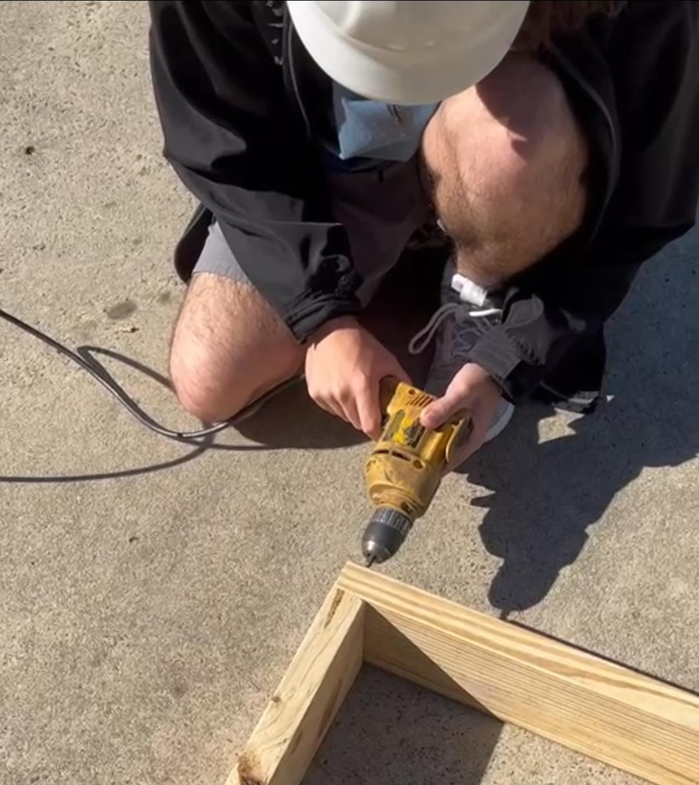 | We screwed in all the pieces of wood using drills and screws.

Mathematics
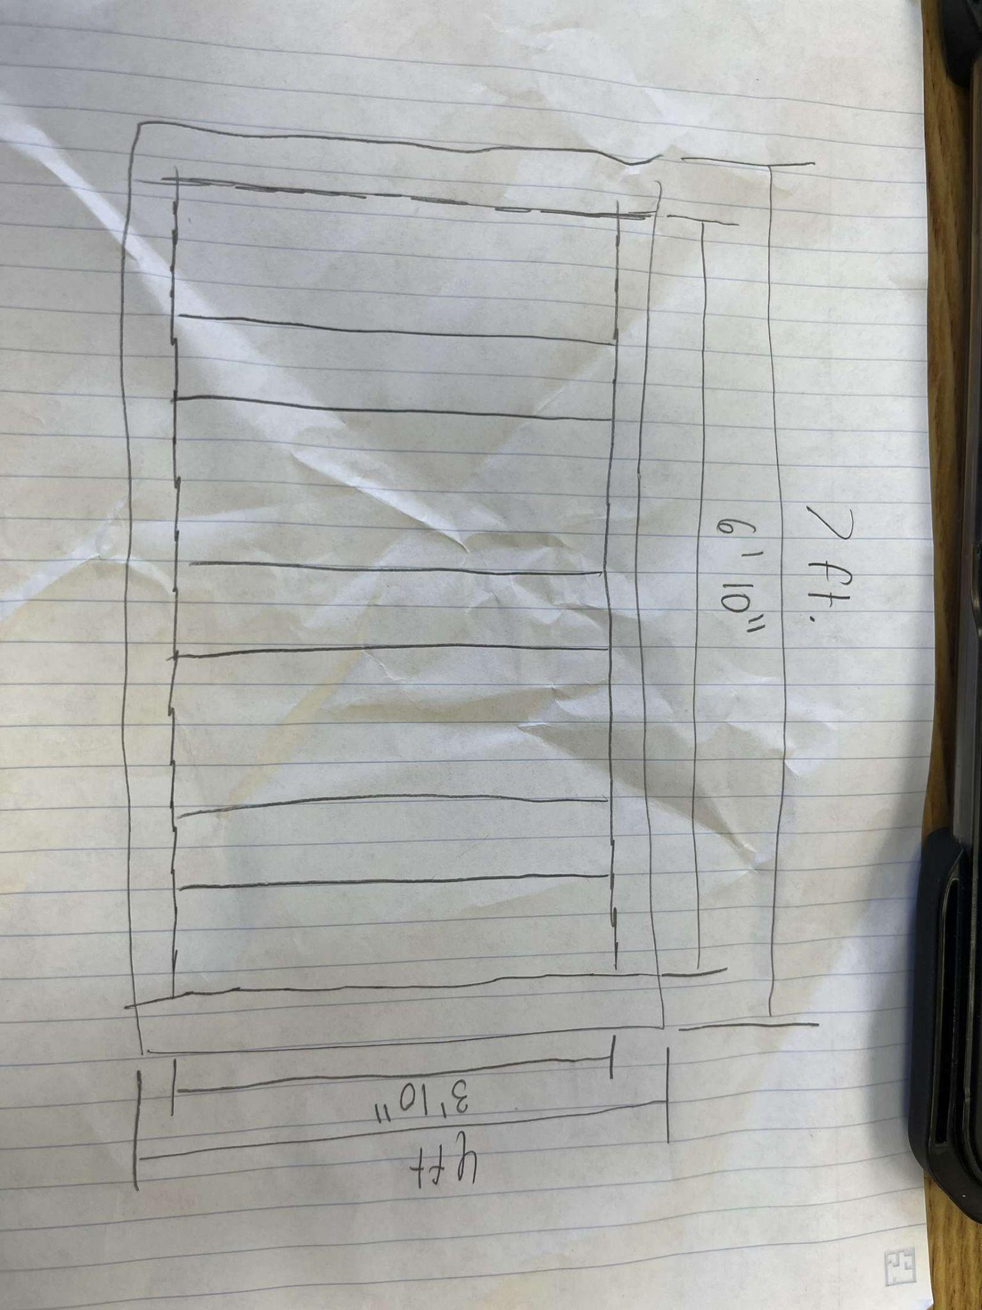 | We calculated the length needed from each piece of wood and how long the inside and outside lengths would be.
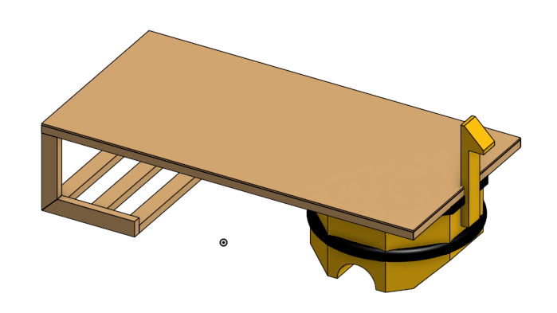 | Used 3D modeling software, Onshape, to design a platform that was to scale based on our measurements.

Conclusion
After looking through all of our STEM principles it is clear that each principle is vital to the solution of the problem. Using Science, Technology, Engineering, and Mathematics we can create any solution to any problem. To answer our problem statement we used all those principles of STEM to plan, prepare, construct, and build our solution. We used science to test materials and stress test our solution. We used tools like wood cutters, 3D modeling software, and an AGV to create a solution. We used engineering to build and put together our pieces of wood as well as 3D modeling our solution. Lastly, we used mathematics to plan and do the math to have correct sizing and measurements for our wood and product.

Element F: Consideration of Design Viability

Problem Statement
Based off a survey taken by high schoolers it was shown that 70% of students found school events mediocre or boring, 61.9% found school provided lunch mediocre or bad, and 75.7% get hungry while traveling. Students need to be energized and have nutrients during school in order to perform their best. When they are hungry and bored they cannot be at their best. By creating a transportable grill better food options can be available to students as well as entertainment.

Introduction
For Element F we continued to research prior solutions and found problems with those solutions that we wanted to improve on. The prior solutions we researched had problems like high costs, no way of movement, and cramped work spaces . We believe that our product will be able to entertain and transport while also maintaining a low cost. Our products can be manufactured cheaper and quickly to be able to meet demand, the product we believe will be able to stand out in the market and be successful.

Market Analysis
Our product fits into many different expansive markets, including ones like entertainment, and the grilling industry. The grilling industry for example is forecast to expand to 3.28 billion USD by 2025.¹
There are many products on the market similar to ours but many have downsides to them, with some downsides being high costs or the need for a device to tow it with.
1- “Global grill and barbecue market- statistics & facts.” Statista, 31 August 2023, https://www.statista.com/topics/8496/global-grill-and-barbecue-market/#topicOverview. Accessed 5 November 2023.

Price Breakdown of Prior Solutions
- Crown Verity CVTG2 ¹ - $10,737.09 per unit.
- Greathouse Labs Multipurpose Grill ² - $650 to construct.
- Moss Grills Ranch Style Barbecue Grill ³ - $2,275.00 per unit.
1 - “';;.'” ';;' - 9 March 2019, https://www.appliancesconnection.com/crown-verity-cvtg2.html?ref=froogle. Accessed 5 November 2023.
² ⁻ Mone, G. (2011, June 23). The ultimate tailgating station combines a TV, wine refrigerator, and Grill. Popular Science. https://www.popsci.com/diy/article/2011-06/ultimate-tailgating-contraption-wraps-tv-wine-refrigerator-and-grill-all-one/
3 - “';;.'” ';;' - 9 March 2019, https://outdoorkitchenpro.com/products/moss-grills-ranch-style-barbecue-smoker-rotisserie-grill-201?variant=40600707072156&currency=USD&utm_medium=product_sync&utm_source=google&utm_content=sag_organic&utm_campaign=sag_organic&srsltid=AfmBOopgvANMAFcWV_7Ag. Accessed 5 November 2023.

Market Research
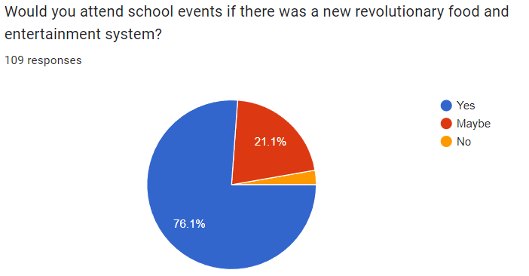
- Conducted from September 6th-11th
- As a result of our survey and this question in specific we believe that many are interested in the advancement of the grill industry with 76.1% saying they would attend school events if our product was there.

Conclusion
We believe that our product would be able to succeed on the market due to its unique attributes and cost efficient measures. Our survey data also proves that people are interested in our product and the advancement of grilling and entertainment. In addition to selling the product it can also generate revenue through being at events and selling stuff like food or other entertainment options.

Element G: Creation of a Testable Prototype

Problem Statement
Based off a survey taken by high schoolers it was shown that 70% of students found school events mediocre or boring, 61.9% found school provided lunch mediocre or bad, and 75.7% get hungry while traveling. Students need to be energized and have nutrients during school in order to perform their best. When they are hungry and bored they cannot be at their best. By creating a transportable grill better food options can be available to students as well as entertainment.

Introduction
For this section, we began the creation of the solution to our problem statement. We had to make sure our prototype fit all the criteria necessary to solve the problem. After we planned and designed for a solution, we began material selection and construction. We had to choose the correct material in order to have a sustainable and sturdy construction. After the material selection we scavenged the school for any parts and materials that would work. We found wood planks and plywood in the engineering work shop. We received permission to use the wood and began construction. We brought tools from our homes to save costs and create convenience. We found new ideas during construction and made iterations as we built.

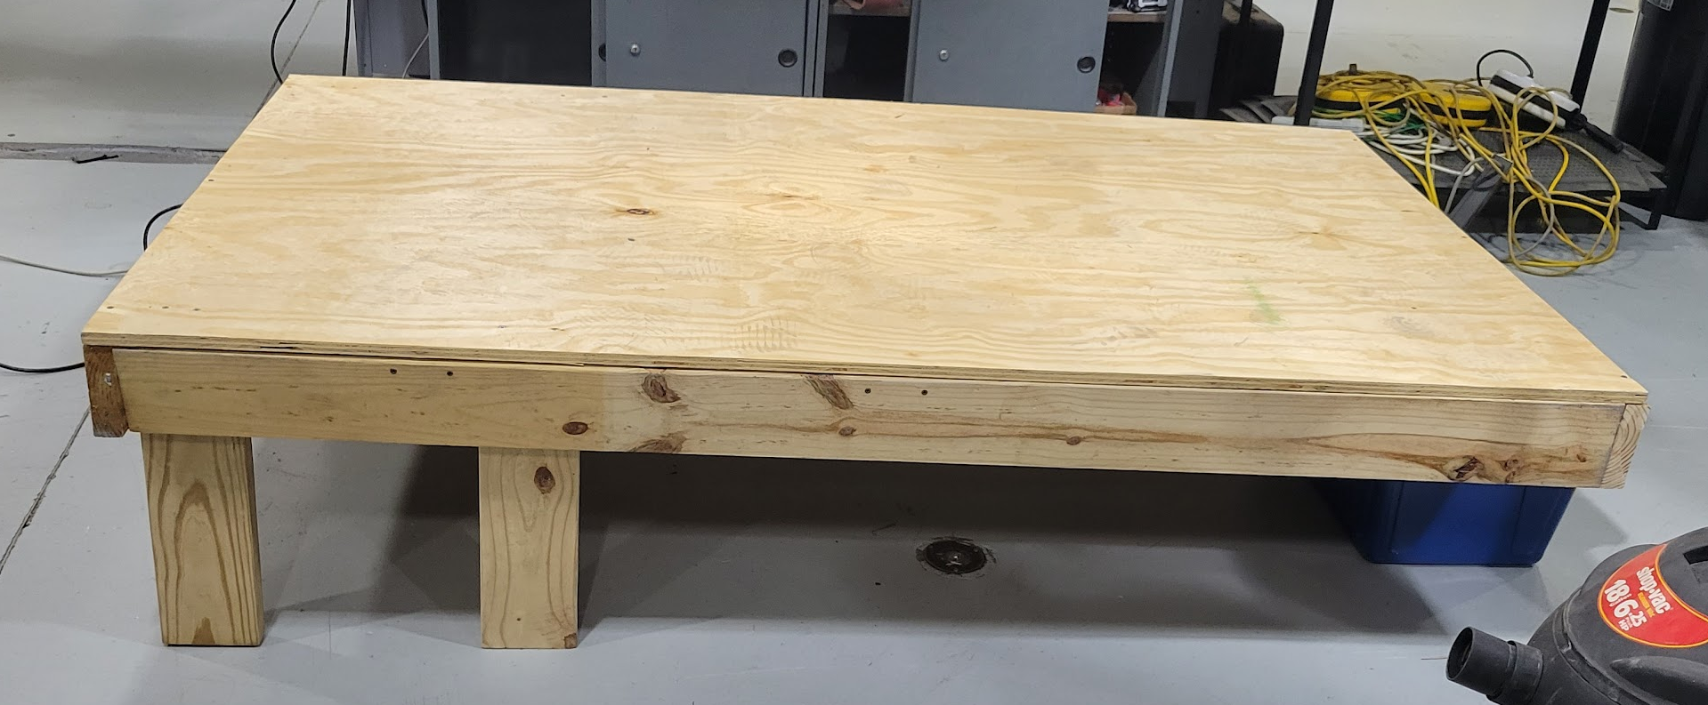
Prototype Construction

Grill Platform:
For the base of the grill we have designed a platform that is spacious for our needs while also not being overly large. The platform was created with 2 by 4 planks of wood cut to specific measurements based on our CAD model. For the assembly of our platform we have used varying sizes of wood screws and bolts to make the structure as secure as possible. The platform was created with the goal of fitting two people and a grill as well as holding the weight of all those things. Many iterations were made during construction as new ideas were discovered. We constructed all this using tools from our homes to save money and make efficiency.
Platform right after the back legs were added.

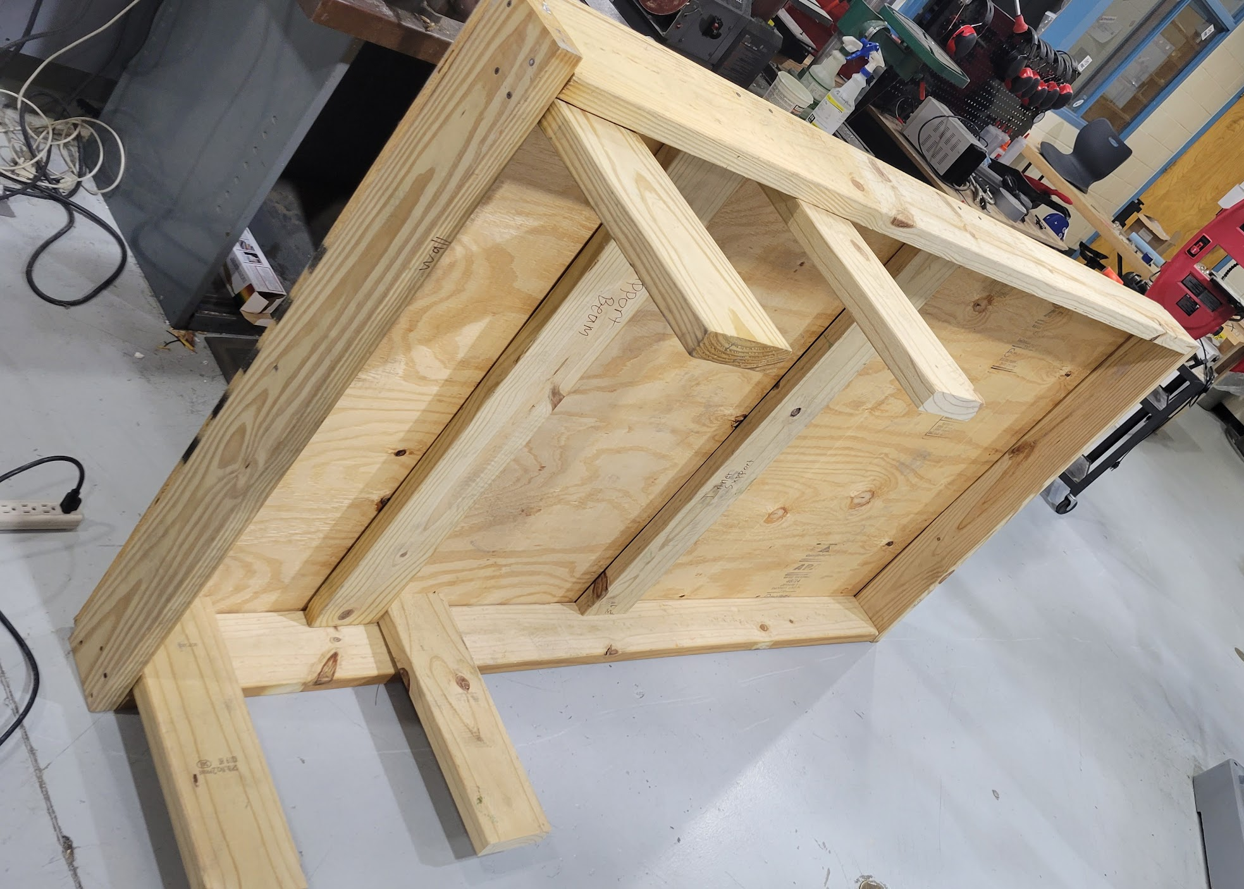
Material Selection:
Since the start of the project we knew that a strong material would be needed to be able to support both people and the grill, but there was also the factors of price and weight limits on the AGV’s. We ended up going with wood due to its high strength and the fact that large portions were available inside the engineering shop. We gained permission to use the wood from various teachers. We choose this out of convenience and strength. The wood had to be stable and in good condition, which the wood was. Outside of the various types of wood we have used, we have also used screws, dolly wheels, and bolts. We used tools such as a drill, wood cutters, hard hats, screwdrivers, and hammers.
View of the underside of the platform

Conclusion
With our prototype we need it to meet certain criteria to be able to hold and move everything we will put on it. The material selection was a good choice as it has now been tested and proven to be able to hold more than one person safely. The construction methods were all stable and well built. We will continue to finish our prototype to match up with our CAD model as well as any new ideas that come to mind. The prototype is almost exact to what we modeled in CAD we feel that we will not be needing to make any major modifications to the design.

Element H: Prototype Testing and Data Collection Plan

Problem Statement
Based off a survey taken by high schoolers it was shown that 70% of students found school events mediocre or boring, 61.9% found school provided lunch mediocre or bad, and 75.7% get hungry while traveling. Students need to be energized and have nutrients during school in order to perform their best. When they are hungry and bored they cannot be at their best. By creating a transportable grill better food options can be available to students as well as entertainment.

Introduction
For this section we looked into our options for how to best test our product and make sure that it is as safe and efficient as possible. We plan on testing the strength of the platform by having people stand on it. Another test we have planned is having people stand on it while it moves to guarantee that it's safe to stand on. These tests will prove the efficiency of our product. If the people felt safe and did not fall then it was safe for people to continue to ride along it. If the platform did not break then it is safe and structurally sound and the finalization of our project can commence.

Testing:
Names: Joseph Masullo, Elie Jerjees, Logan Kerstiens, Gavin Jackson
Testing Summary:
Structural Test: determining the strength and the stability of the platform.
Testing Date: 11/27/23
Testing Location: 600 Brewer Drive, CATA, Engineering Shop
Purpose:
After construction of the initial platform we had to make sure it was stable enough for the purpose of our project.
Pass/Fail Criteria:
The test will be a pass if people are able to stand on top of the platform without any bending in the wood, or worse make the platform collapse.
Materials:
- Platform
Initial Conditions:
- Platform is set up in a clean spacious area
- Front of the platform is secured so it can't roll away

Safety Concerns:
Hazards | Controls | Completed
Platform starts to roll | The platform was secured to not move. | It did not roll.
Platform starts to crack | Have people not on the platform safely get those on it off. | The platform did not crack.

Test Termination:
- Terminate the test if any of the following conditions occur:
  - Platform starts to bend a lot
  - Platform begins to crack
  - Platform starts moving
Data:
Amount of People | Did the Platform Hold?
1 | Yes / No
2 | Yes / No
2+ | Yes / No

Procedure:
- Get personnel for the test
- Check area for any hazards
- Make sure the platform is mounted to something secure
- Get the people on top of the platform
- Have the people walk around and test the sturdiness of the platform
- Have someone take a picture if there is any deflection
- Get the people safely off the platform

Names: Joseph Masullo, Elie Jerjees, Logan Kerstiens
Testing Summary:
Movement Test: Testing the structural stability of the platform while the platform is in motion.
Testing Date: 11/30/23
Testing Location: 600 Brewer Drive, CATA, Engineering Shop
Purpose: We tested the wheels that were put on the platform and how much they could hold. For the purposes of our platform no more than 2 people need to stand on the platform, because of that we had two people standing on it while a third pushed it around. We had to make sure that the platform was mobile while also being stable.
Pass/Fail Criteria:
The test will be a pass if people are able to stand on top of the platform while it is moving without any bending in the wood, making the platform collapse, or anybody falling off.
Materials:
- Platform
- Wheels
- People
Initial Conditions:
- Platform is set up in a clean spacious area
- Platform has space to move freely
- Platform can be

Safety Concerns:
Hazards | Controls | Completed
People fall off | Platform is balanced and secure so nobody will slip, trip, or fall off. | Nobody fell and the platform was stable.
Platform starts to break | Have students safely come off of the platform so avoid falling through and injuring themselves. | Nothing broke and the platform was structurally sound.

Test Termination:
- Terminate the test if any of the following conditions occur:
  - Platform starts to bend a lot
  - Platform begins to crack
  - Student falls off
Data:
Amount of People | Did the Platform Hold while rolling?
1 | Yes / No
2 | Yes / No
2+ | Yes / No

Procedure:
- Get personnel for the test
- Check area for any hazards
- Get the people on top of the platform
- Have the people walk around and test the sturdiness of the platform
- Wheel the platform around safely
- Determine the stability and safety of each person on the platform.
- Have someone take a picture if there is any deflection
- Get the people safely off the platform

Conclusion
For our prototype we had to test it to make sure everything was in order for the preparation of the final prototype. We tested the structural integrity of the platform by having 3 people stand and jump on the platform. We determined that it was safe because they all stood without falling and the platform held up even while they jumped. Next we tested if the platform can move safely without anyone falling off of it. We had one person at a time stand on it while we moved it around and added more people gradually. We determined that it was safe to move around because all the people felt safe, did not fall, and the platform did not deflect or crack. Now that it has been tested we are ready to finalize the prototype.

Element I: Testing, Data Collection and Analysis

Problem Statement
Based off a survey taken by high schoolers it was shown that 70% of students found school events mediocre or boring, 61.9% found school provided lunch mediocre or bad, and 75.7% get hungry while traveling. Students need to be energized and have nutrients during school in order to perform their best. When they are hungry and bored they cannot be at their best. By creating a transportable grill better food options can be available to students as well as entertainment.

Introduction
For testing our prototype, we set up a safe environment inside the CATA Engineering shop and gathered volunteers to help conduct our tests. To prove that our platform met design requirements we put it through various tests to ensure structural safety and movement capabilities. With testing we want to find what can be improved upon and what is necessary for the functionality of the prototype.

Test Results and Data Collection

Structural Test
Amount of People | Did the Platform Hold?
1 | Yes / No
2 | Yes / No
2+ | Yes / No
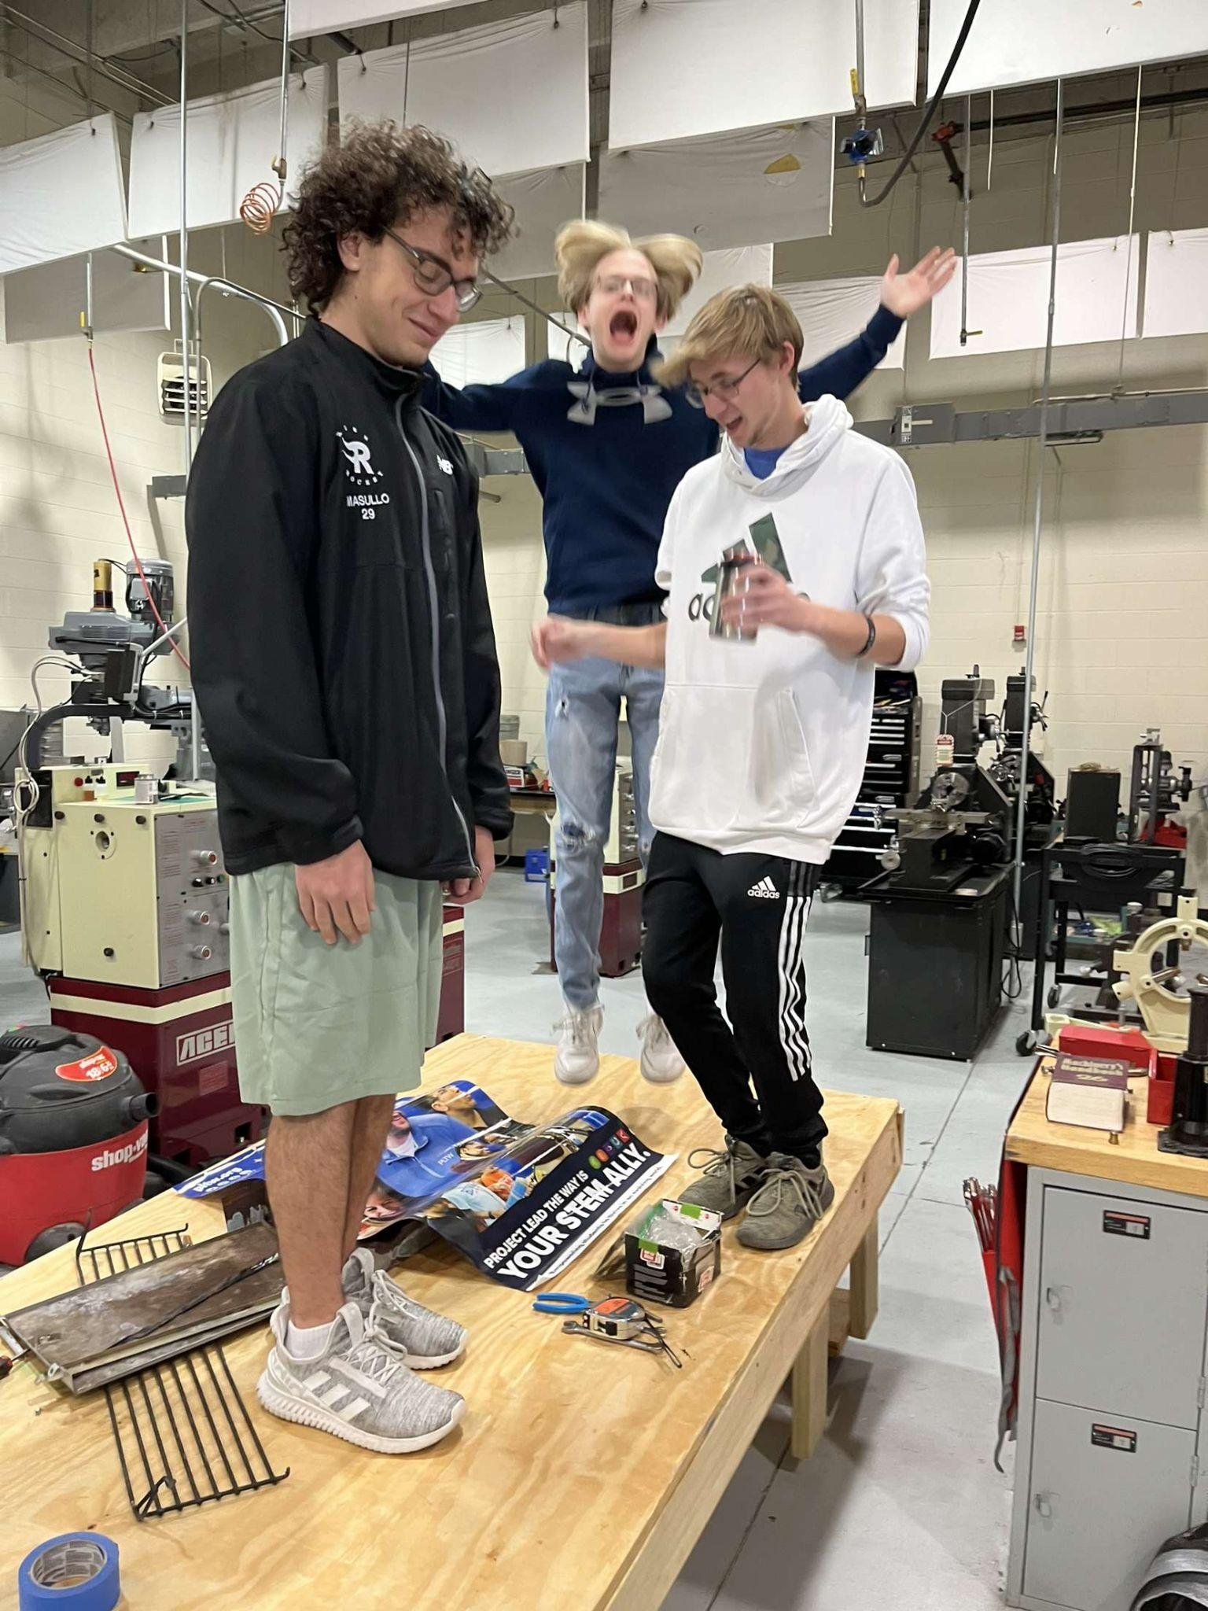
Below are several photos that were taken to show the test that had 2+ people on the platform.

zz

Pictured: A test where 3 people are securely standing on the platform

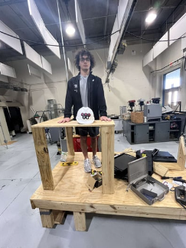
Pictured: A test where Joey stands on the platform with the workstation securely.
The results from this test were consistent with what we wanted out of our design. Our plans called for multiple people to securely stand atop the platform and with our tests we have validated that it's possible.

Rolling Test
Amount of People | Did the Platform Hold while rolling?
1 | Yes / No
2 | Yes / No
2+ | Yes / No
Below is a photo that was taken to show the test
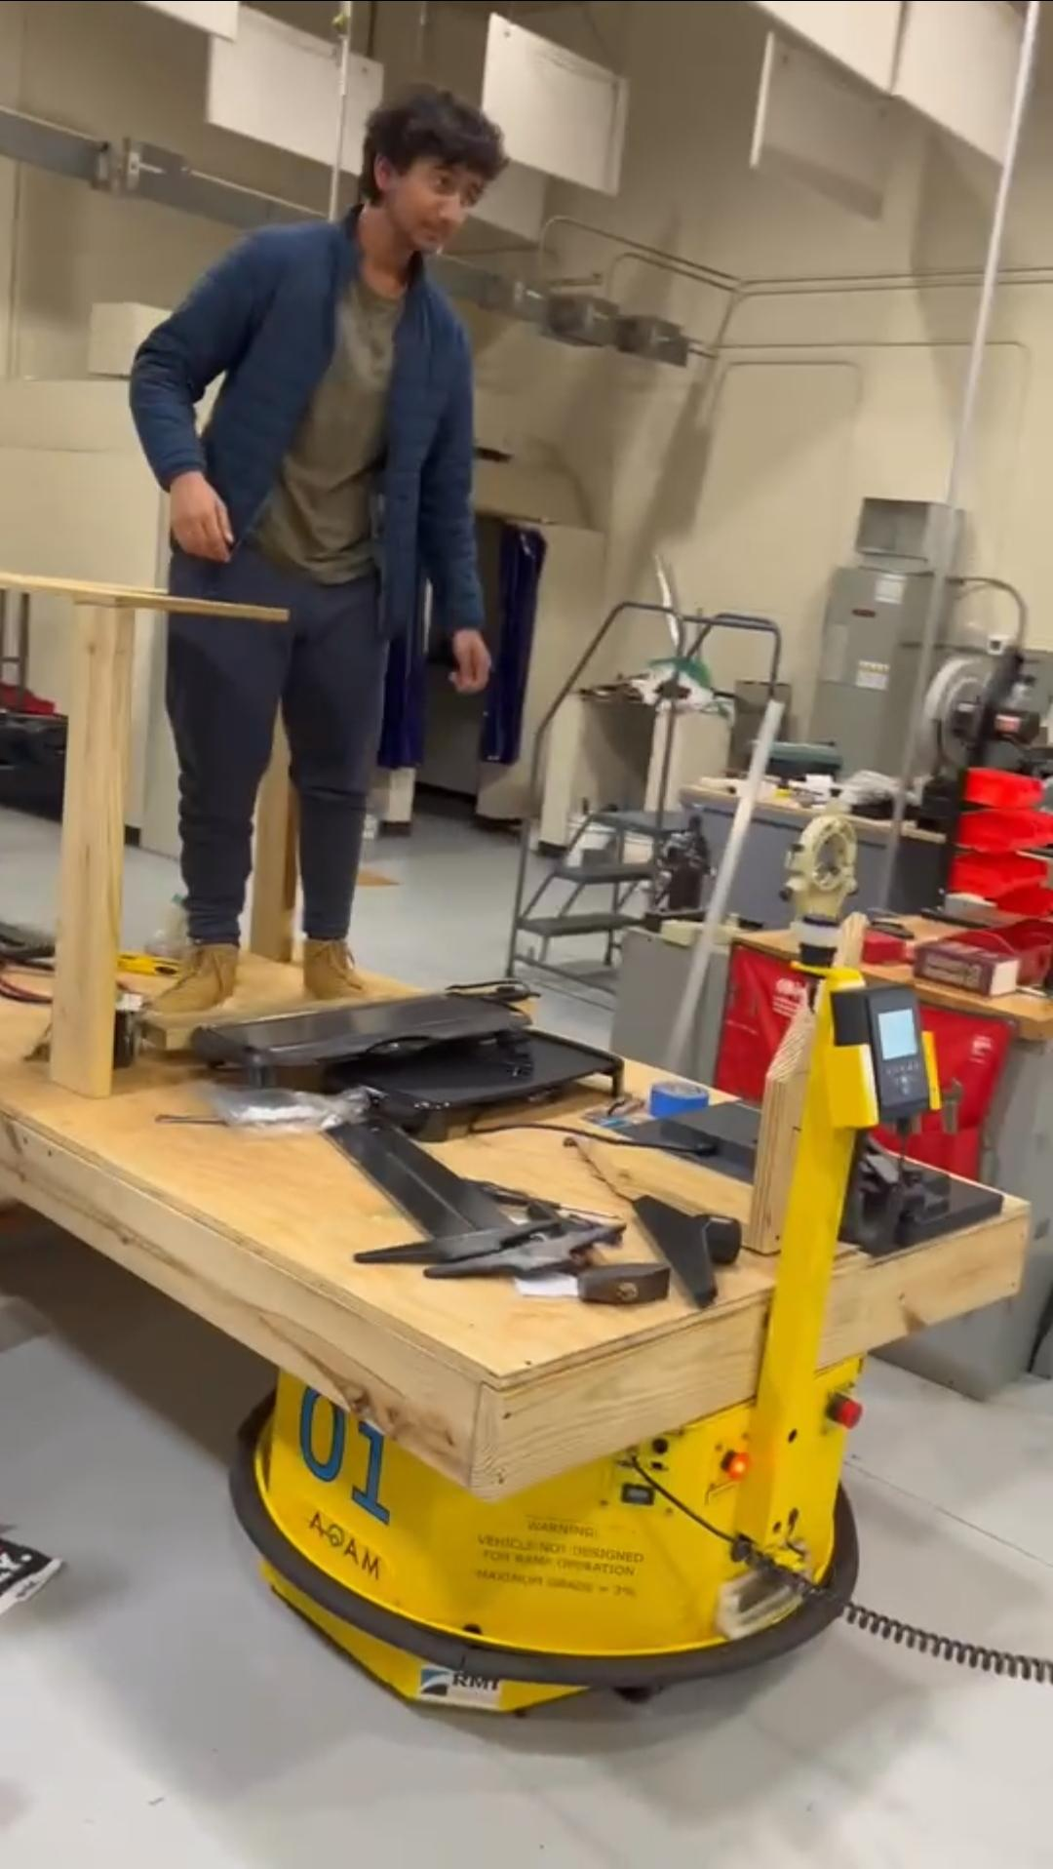
Amey Sharma tests out the rolling capabilities of the BBQ 2.0
The Results from this test showed that we are able to move the platform while having people stand on top of it. The results are consistent with what we intended, and we believe that we will be able to have multiple people safely on the platform while moving.

Analysis
After finishing out testing we have taken note of everything that has been completed and everything that needs improvement. The frame of the platform is stable and has been completed with no further work necessary. After completing the structural test we have determined that it is ready, but if extra materials and time is given we may add extra support beams to create a less creaky platform. For the movement test, we find that if we can make our platform move and turn with more ease it will be less likely that any issues occur. It was safe while moving, but the turning mechanism could be improved. After putting the AGV under the platform to do a final driving test we have found that it can be improved upon the most. The AGV can move the platform with ease, however, it is slow and the turning mechanism causes issues. The AGV turns on its own axis rather than doing a moving turn. This causes issues because the grill moves the way a car moves while the AGV turns in circles then moves. We will attempt to fix this by either bolting the AGV to the platform, or building a beam that will attach to the AGV so they all move together. Overall, the platform is ready for the next stage of production and any modifications made will only be improvements rather than necessary changes to make it operational. The product now functions and any improvements will only be for the betterment of the product rather than the functionality.

Conclusion
In conclusion of this part, we have finished all testing until any further improvements are made. The testing proved that our product is operational and can function how it was intended. Changes were made to the initial design for a more efficient and probable prototype, but all the changes made now are now functional. Improvements may be made but the functionality is now working and will continue to work even with improvements. In the future we want to add more electrical components successfully and add more overall safety.

Element K: Reflection of the Design Project

Problem Statement
Based off a survey taken by high schoolers it was shown that 70% of students found school events mediocre or boring, 61.9% found school provided lunch mediocre or bad, and 75.7% get hungry while traveling. Students need to be energized and have nutrients during school in order to perform their best. When they are hungry and bored they cannot be at their best. By creating a transportable grill better food options can be available to students as well as entertainment.

Introduction
Looking back to the start of the project we believe that our final prototype met what our design called for given the time and budgetary constraints. As a team we believe that we worked great together and were on the same page throughout the entire design process. Outside of a change made to the cooking device we believe that there are not many changes we would make to the prototype given the constraints.

Element A
In Element A we set a problem statement. We determined what was the most necessary criteria in our product and what we needed to solve and write it up as a problem statement. From that point we worked to solve this problem through our product. We also conducted a survey with students and staff at CATA to both prove our problem and show that it was a problem worth solving.

Element B
For Element B we began to research various patents and existing products that were related to what we wanted to do. With our research we were also able to take and improve on ideas that we had found within the existing patents and products. While it was difficult to find patents and products that were exactly related to our project we were able to find closely related products like food trucks and portable grills. We believe with more time we would have been able to find closely related products to ours.

Element C
In Element C we started to lay out who our stakeholders were. With this set we were able to start designing the solution with our stakeholders in mind. We felt that to successfully solve the problem we needed to create it for the stakeholders.

Element D
For Element D we started to come up with design solutions for our product. We used CAD modeling software to create solutions that fit within our criteria. Throughout the process we improved on our design with new models. We then created a design matrix to help evaluate what the best design would be.

Element E
In Element E we explained how the different principles of STEM applied to our project. For Science we explored different materials to help create the best possible platform. For Technology we are using an AGV (automated guided vehicle) to move our platform. For Engineering we sketched out designs and measurements for our design. For Mathematics we calculated the length we needed each piece of wood.

Element F
We began research to determine what our best design would be. Our project is too large to design multiple products and test them all out, so we had to be sure of our design before construction. We had to ensure there were safety measures, efficiency, and mobility. We designed our product to be able to mount a whole grill initially as well as having multiple legs with wheels. When building we reiterated the design and switched it to a table to hold table top grills. We made many adjustments in order to make the product the best possible product.

Element G
In Element G we began working on our prototype. We had planned multiple ideas beforehand and decided on one because we could not afford the money nor time to create multiple prototypes. We began by using extra wood in the engineering shop to create a rectangular base. From that base we added support beams. We then began to add legs onto the platform to make it stand. We added support beams that could be used as a basement to hold extra materials and needed things onto our product. Afterwards we added wheels so it could move with ease. We began to mount the AGV onto the platform to see if it works. After it had proven to work we added a table to hold our table top grills. We then found a power inverter and added it to our product in order to power our grills. We made slight improvements after that, for example we made sure ADAM was secure in order to pull around the platform without issues.

Element H
During Element H we decided on what parts were the most important to our design. We decided these things on factors of safety, efficiency, and usage. We then designed tests to determine if those parts work in the intended way. The procedures were made to ensure our product works without damage to the product or the people. We took data to measure the results in order to make the necessary improvements.

Element I
For the testing of the product we ran through the planned procedures that were created in Element H. We tested the mobility of the platform by running it with ADAM back and forth as well as turning left and right. We then tested the structural integrity by having multiple people stand on it, jump on it, and even ride it. After determining it was mobile and structurally sound, we decided it was safe and needed no further improvements.

Conclusion
In conclusion, our final engineering project, BBQ 2.0, was a full success in every aspect of the word. We ran through minimal issues and worked diligently to solve the problem statement. Through months of relentless work, the BBQ Team accomplished all the goals that were planned and went beyond to create excellence in the form of moveable BBQ. Through the combination of professional, personal, and emotional work, we created something that was more than a project. We created a lifestyle. Not only did this project solve an issue, but it created far more. It created bonds between friends that will last for lifetimes. Share a BBQ with someone, they will remember it forever. BBQ 2.0 has become more than a mere engineering project. BBQ 2.0 in its essence has become love in its truest form. Our assignment birthed the neverending imagination of engineers, our consumers are not customers, but lovers of ingenuity. We want to thank you for being on this ride with us, BBQ 2.0 signing off.
